Samba File Server

**Michael Kohronas**

**10/30/2023**

**Project Portfolio: III**

Table of Contents

Step 1: Change hostname of VM – 3

Step 2: Make sure ubuntu is updated – 4

Step 3: Install Samba Server 4

Step 4: Create a samba user and password associated with the user “user” on the ubuntu machine. 5

Step 5: Create a folder for samba and create a backup. 6

Step 6: Create a share for the samba folder: 6

Step 7: Restart the smbd service and testparm for the service to make sure code is working 7

Step 8: Install the SMBD client 8

Step 9: find the hostname IP then smb into the server file and check the shares available. 9

Step 10: Create user1 and repeat the previous steps 10

Step 11. Create a milestone 2 folder & assignment2.txt 11

Step 12: Add permission to the new directory created 12

Step 13: connect on windows via the run window 13

Step 14: Confirm it worked by checking the file on the ubuntu machine 13

# 

# Step 1: Change hostname of VM –

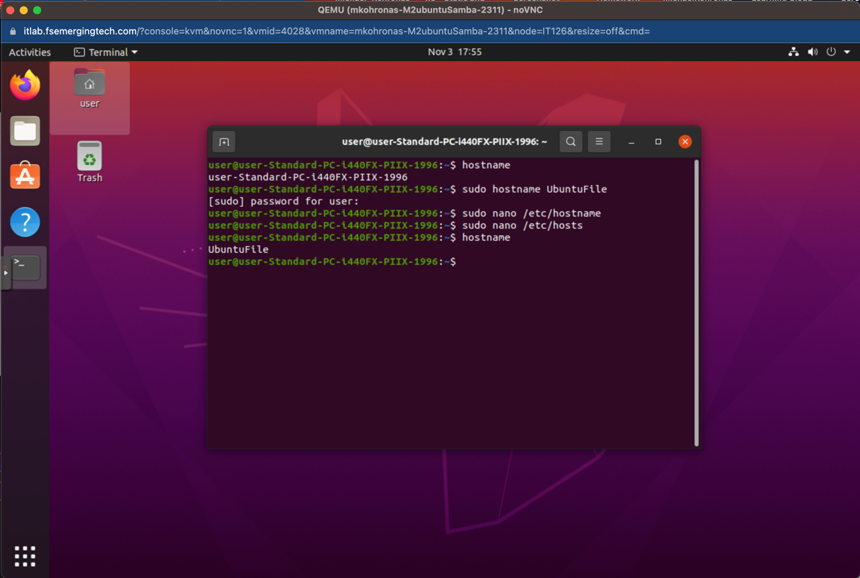

# Step 2: Make sure ubuntu is updated –

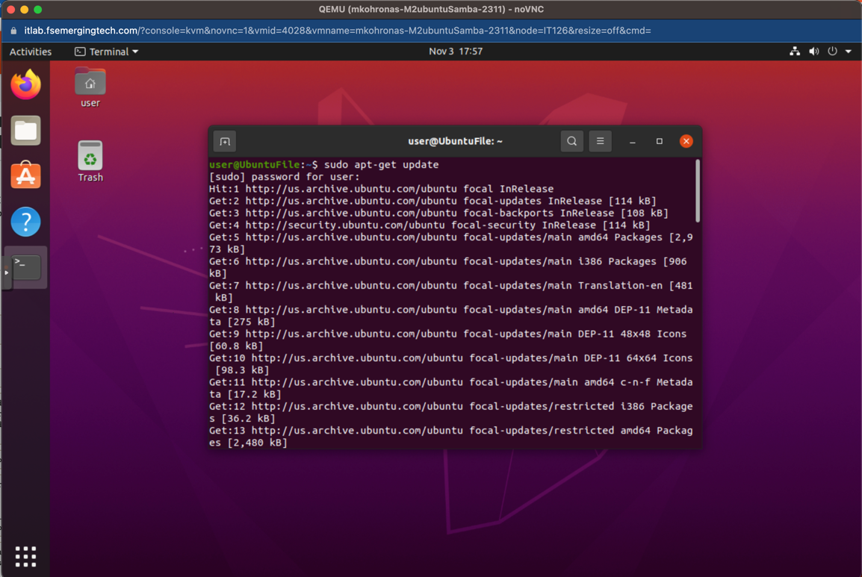

# Step 3: Install Samba Server

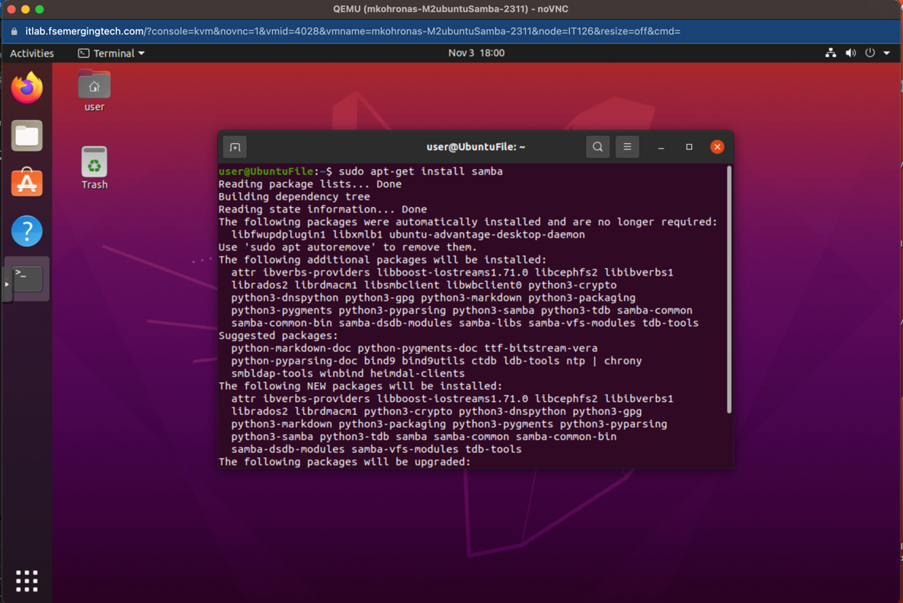

# Step 4: Create a samba user and password associated with the user “user” on the ubuntu machine.

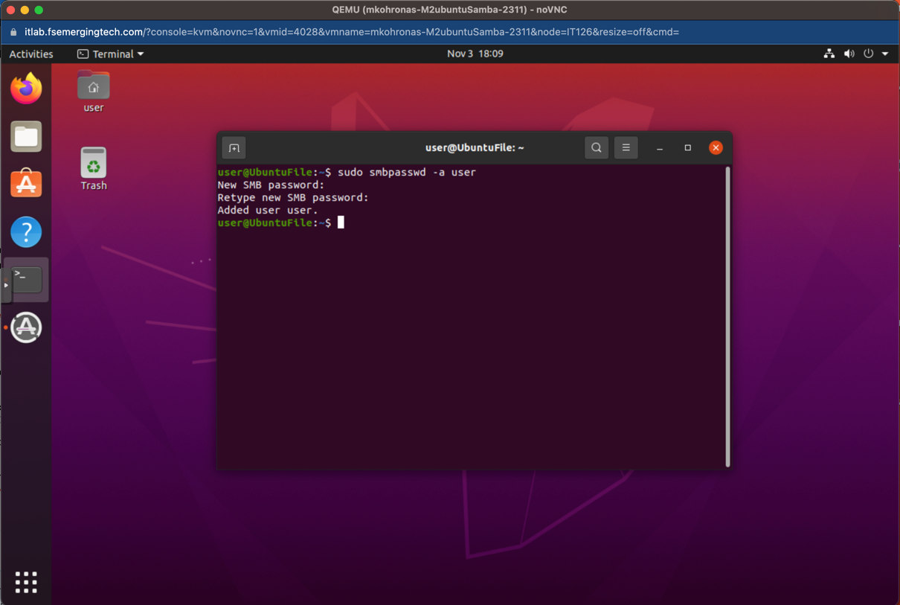

# Step 5: Create a folder for samba and create a backup.

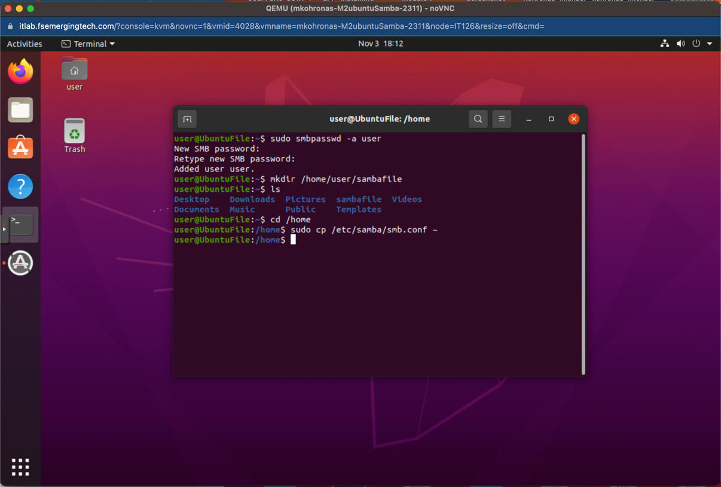

# Step 6: Create a share for the samba folder:

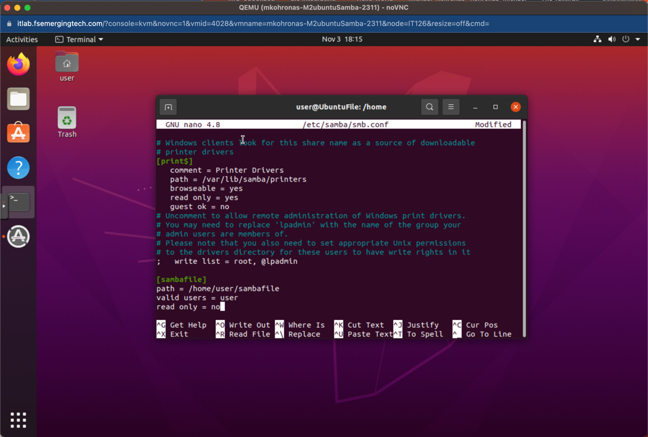

# Step 7: Restart the smbd service and testparm for the service to make sure code is working

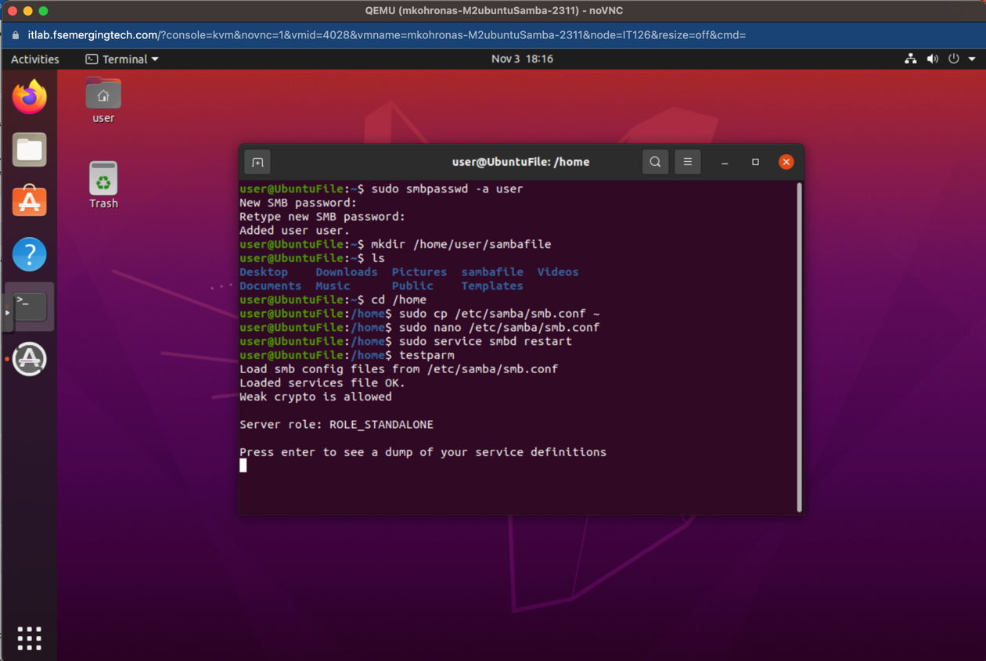

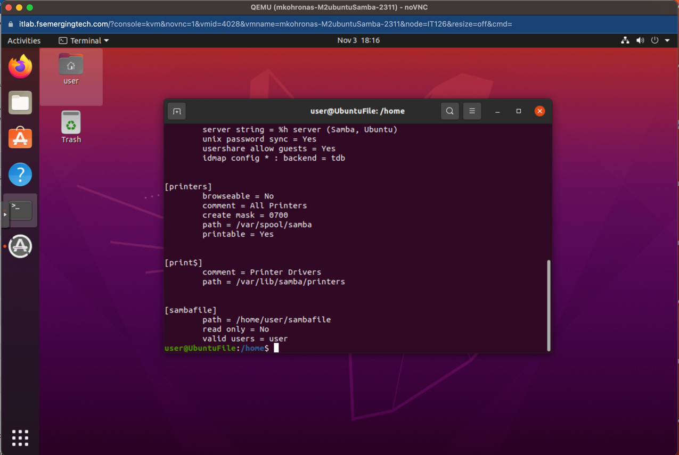

# Step 8: Install the SMBD client

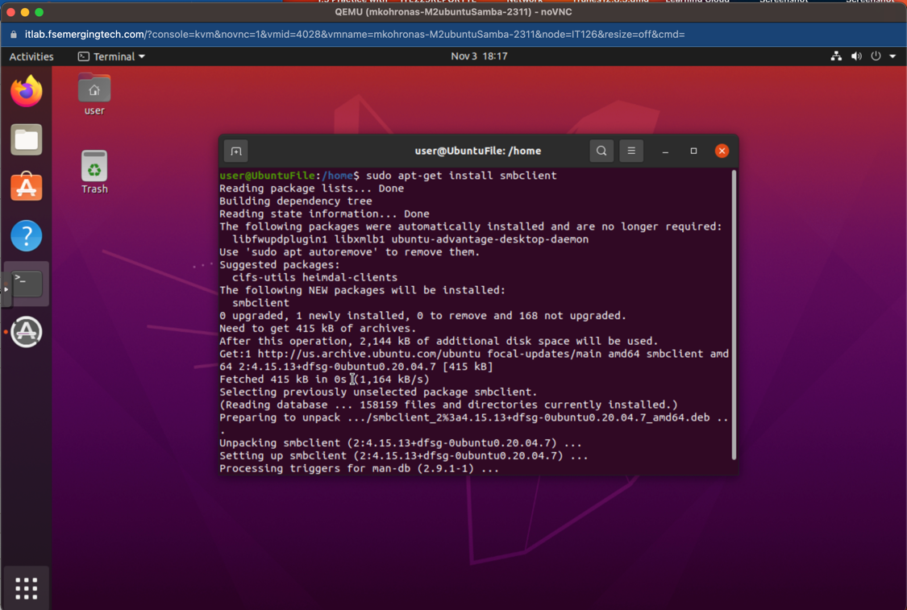

# Step 9: find the hostname IP then smb into the server file and check the shares available.

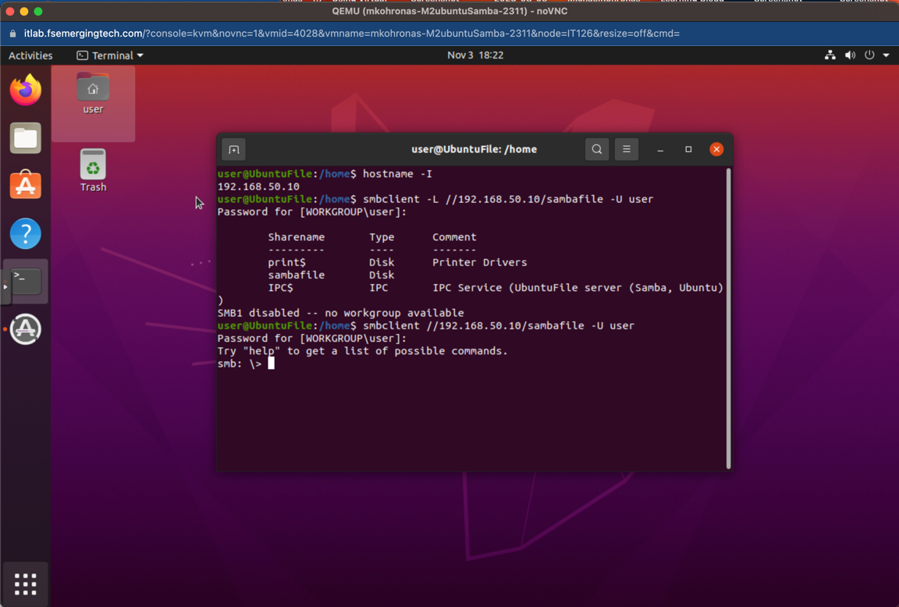

# Step 10: Create user1 and repeat the previous steps

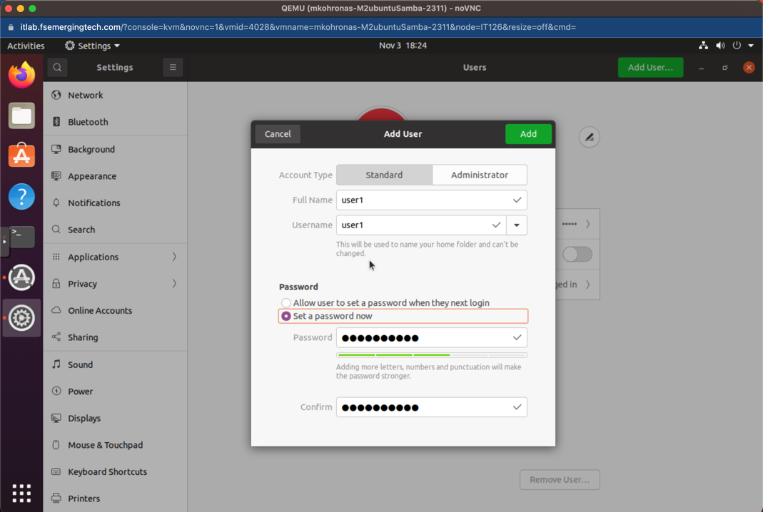

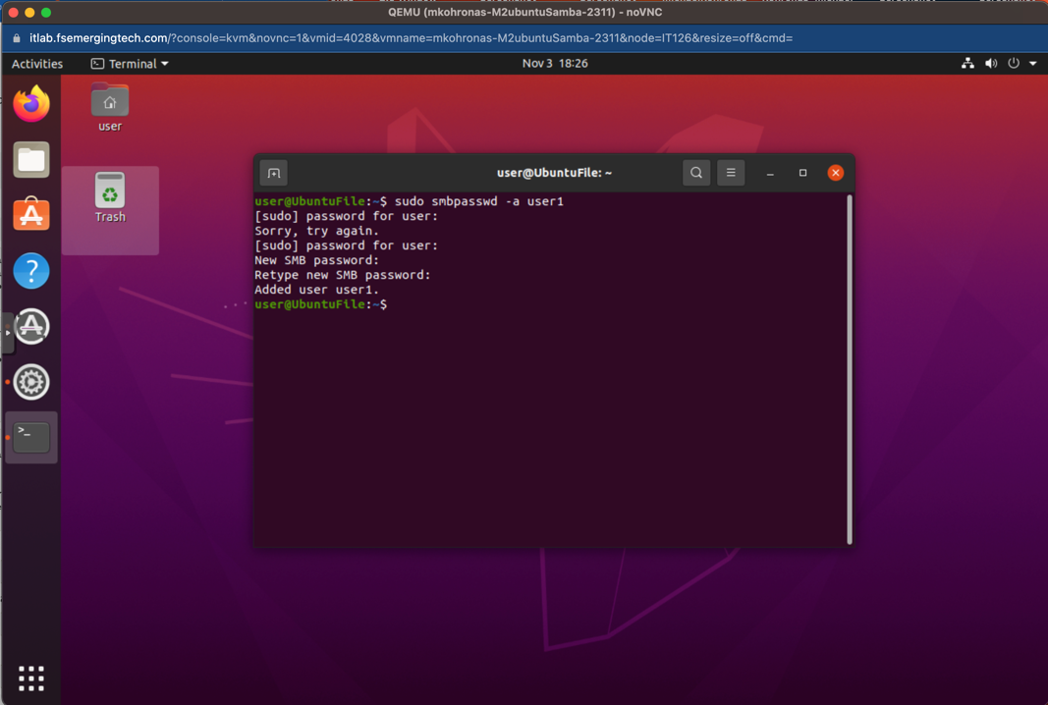

# Step 11. Create a milestone 2 folder & assignment2.txt

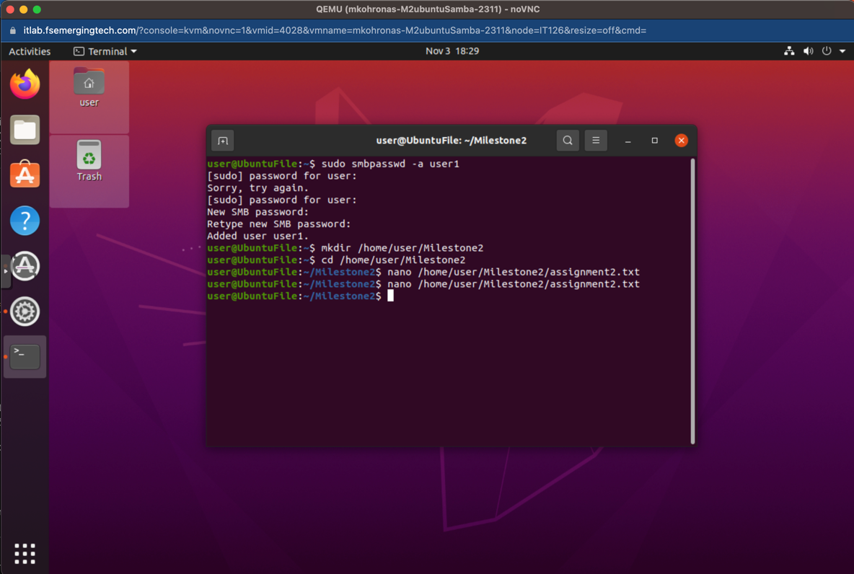

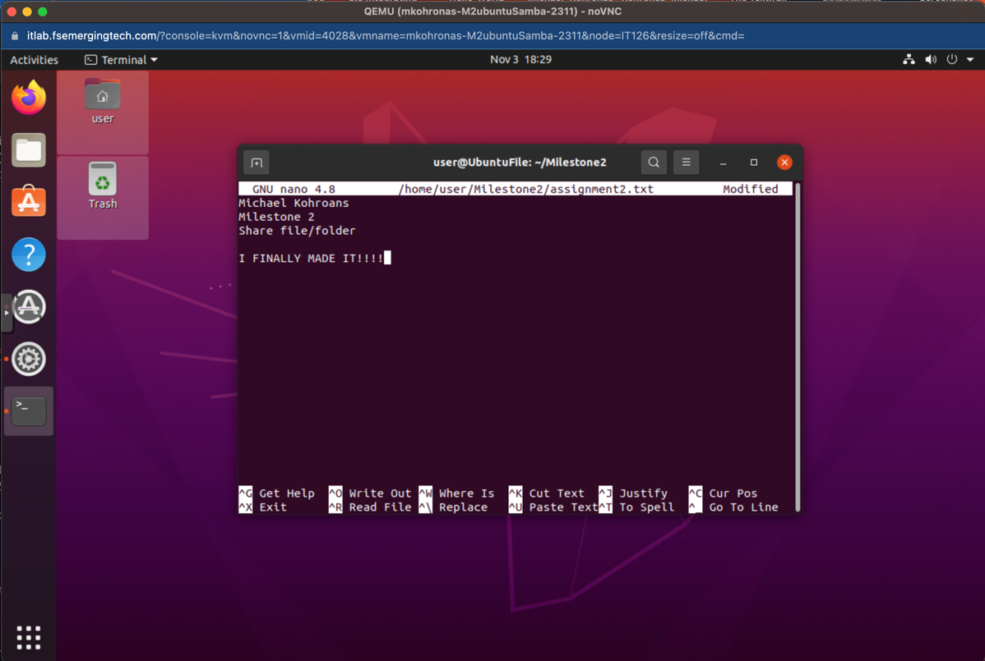

# Step 12: Add permission to the new directory created

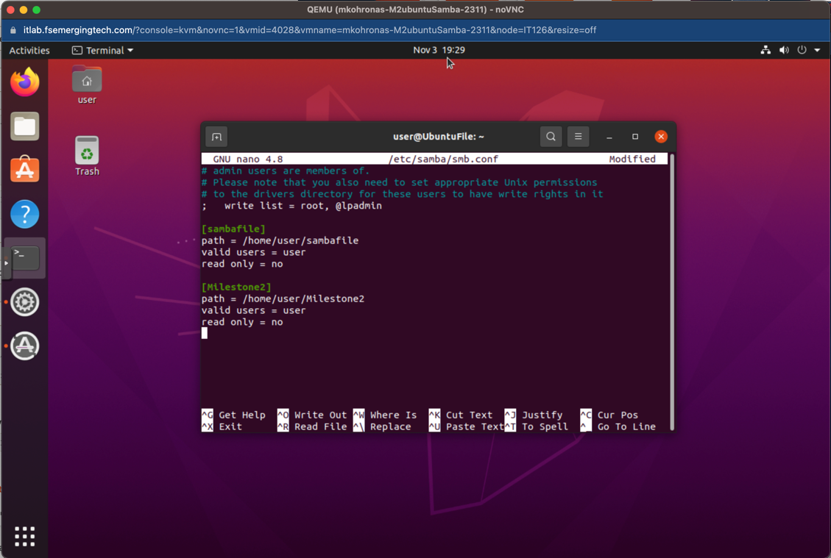

# Step 13: connect on windows via the run window

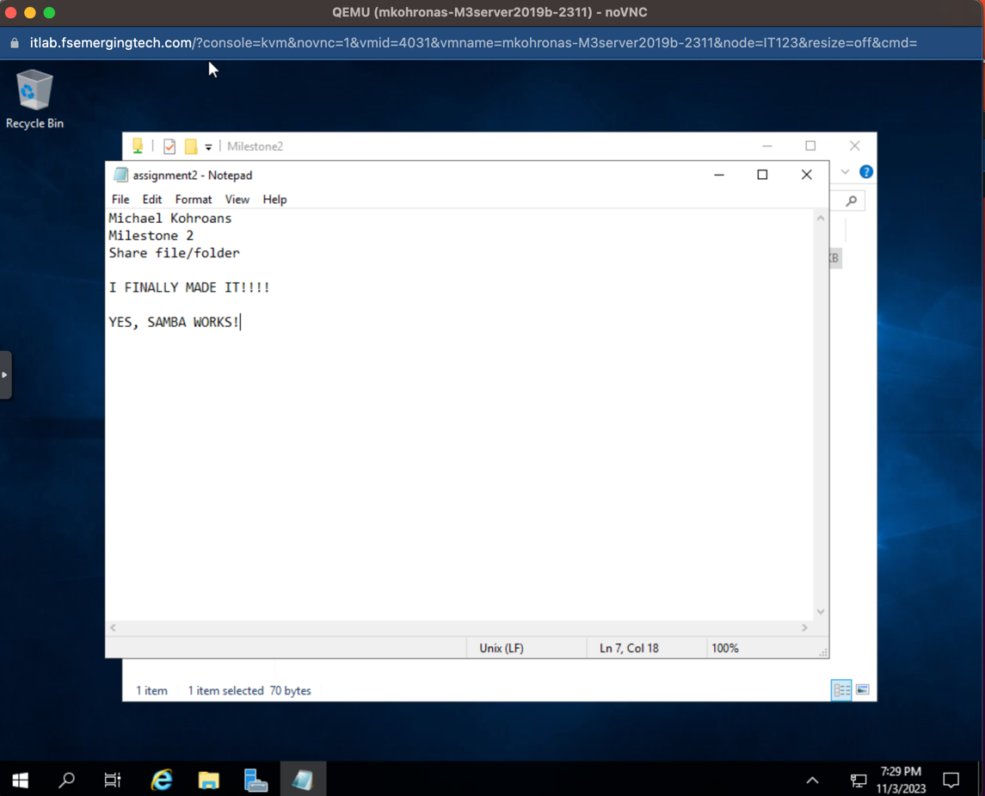

# Step 14: Confirm it worked by checking the file on the ubuntu machine

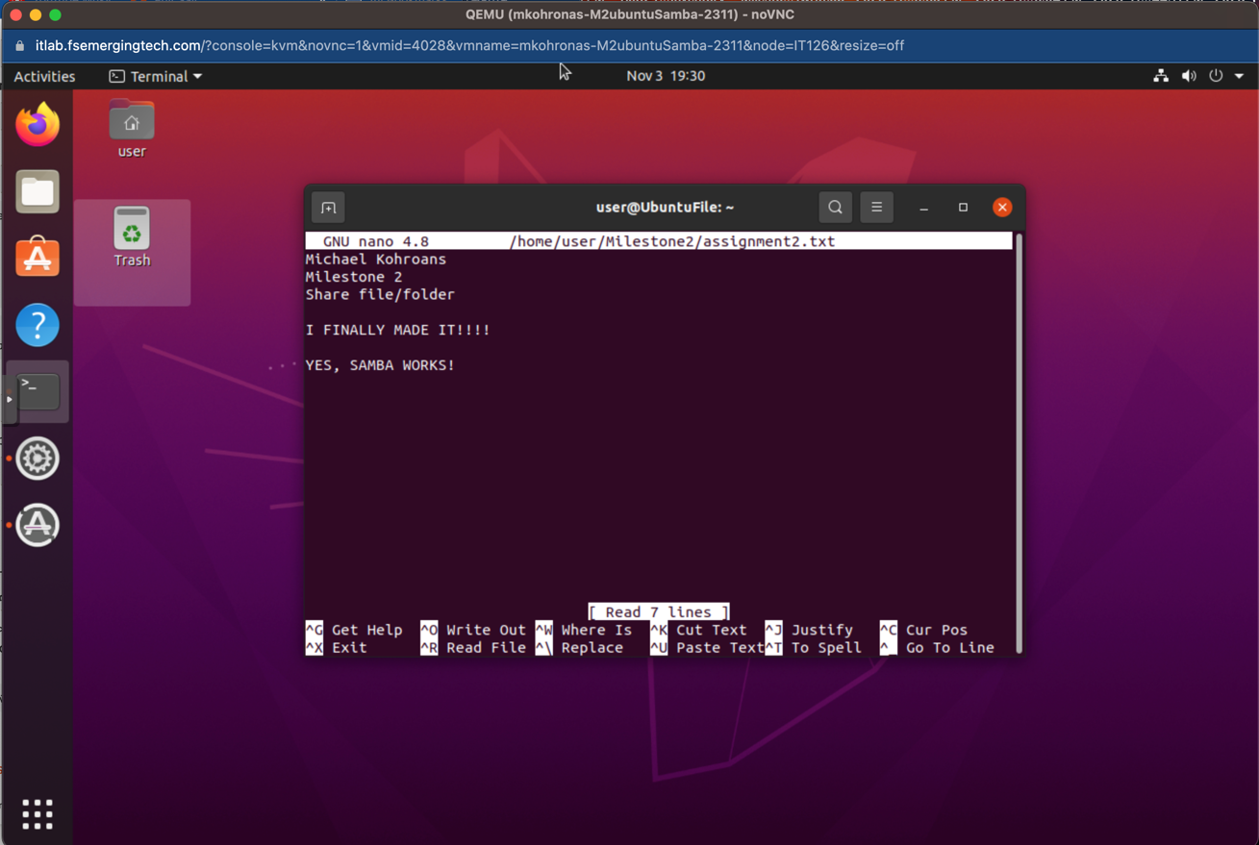

# References:

<https://help.ubuntu.com/community/How%20to%20Create%20a%20Network%20Share%20Via%20Samba%20Via%20CLI%20%28Command-line%20interface/Linux%20Terminal%29%20-%20Uncomplicated%2C%20Simple%20and%20Brief%20Way%21>

<https://help.ubuntu.com/community/How%20to%20Create%20a%20Network%20Share%20Via%20Samba%20Via%20CLI%20(Command-line%20interface/Linux%20Terminal)%20-%20Uncomplicated,%20Simple%20and%20Brief%20Way>

<https://www.youtube.com/watch?v=vyatMj1Z2NQ&ab_channel=TechReview>